The Career Finder Sprint Report

Team Savage – Davyn Savage, Mayowa Ayeni, Stephen Sayers

# 

The Career Finder Overview 4

Sprint 1 Report 5

Sprint Planning/Estimation: 5

Next Sprint Tasks: 5

Retrospective Summary of Responses: 5

Retrospective Responses Sprint 1: 6

Sprint Tasks Sprint 1: 7

Backlog of Sprint Tasks: 8

Final Hours: 9

Sprint 2 11

Sprint Planning/Estimation 11

Product Backlog: 12

Sprint Backlog: 13

Hours: 14

Sprint Review: 17

Retrospective: Table of Responses: 18

Retrospective: Summary of Responses: 19

Sprint 3 20

Sprint Planning/Estimation 20

Product Backlog: 21

Sprint Backlog: 22

Hours: 23

Sprint Review: 31

Retrospective: Table of Responses: 32

Retorspective: Summary of Responses 33

Project Debrief 34

Appendix 35

A. Final Presentation 35

B. Context Analysis, WAAD Creation & User Story Generation 43

C. Contextual Inquiry & Analysis 51

D. Setup 53

E. Initial Design (Wireframe) 54

F. Sprint Planning Meetings 59

G. Sprint Reviews 62

## 

## The Career Finder Overview

Welcome to the Career Finder Project report, a cutting-edge tool created by Team Savage to transform professional and student career exploration and decision-making. This report outlines our methods, the technology we used, and the lessons we learned along the project lifecycle. It also recounts our journey from inception to conclusion. You will find thorough evaluations of our planning phases, development sprints, and the different obstacles we overcame to produce a reliable and user-friendly platform as you go through this article. Our goal is to not only present our effort but also offer a model for other projects in the field of tech-driven career counseling. (Response assisted with ChatGPT)

# Sprint 1 Report

## Sprint Planning/Estimation:

When planning this sprint our team kept it’s conservative view when picking tasks. While we wanted to increase the workload (seeing as we had underestimated the previous sprint) the tasks for this sprint seemed very labor-intensive and members also had quite a bit of work for other classes so we wanted to give ourselves the right mix so that we didn’t fall behind. We aimed to get epic 4 finished by the end of the sprint again, like with the previous sprint, giving ourselves the ability to pick up more tasks as they come. We assignment Mayowa to ChatGPT implementation and template design to Stephen. Savage was to continue putting team materials together and help where needed. We believed this to be achieve able given what we achieved in the last sprint. We also recognized epic 4 as sort of a placeholder for epic 5.

## Next Sprint Tasks:

Based on how it looks Epic 4 or 5 will be next on the agenda as we don’t perceive this sprint as being one where we fall behind. Rather we expect we’ll have extra time to work on other tasks.

## Retrospective Summary of Responses:

We had a range of emotions during our sprint, from a sense of satisfaction to occasional confusion. We committed ourselves to continuous work, such refining the design of the main page, building strong user interfaces for the basic and detailed versions, and improving the overall user experience by adding smart features like body links, formatted content, headers, and a fresh look for the homepage. In addition, we designed progress indicators and improved the user interface for our tests, resulting in a "completion" page that indicates the end of a task. Our advancement is primarily due to excellent communication and a team effort that is very focused. We were skilled at keeping the client and each other in sync, which allowed us to move closer to our objectives—like the polished user interfaces that are prepared for integration. In order to maintain our successful procedures and avoid confusion in the future, we must improve our communication with the client and our associates. It is critical that we establish a constant, clear knowledge of standards and strengthen our teamwork. The obstacles of uncertainty, we successfully managed the intricacies and came out on top with noteworthy successes. The voyage was turbulent but rewarding, characterized more by adaptability and learning than by simple setbacks.

## Retrospective Responses Sprint 1:

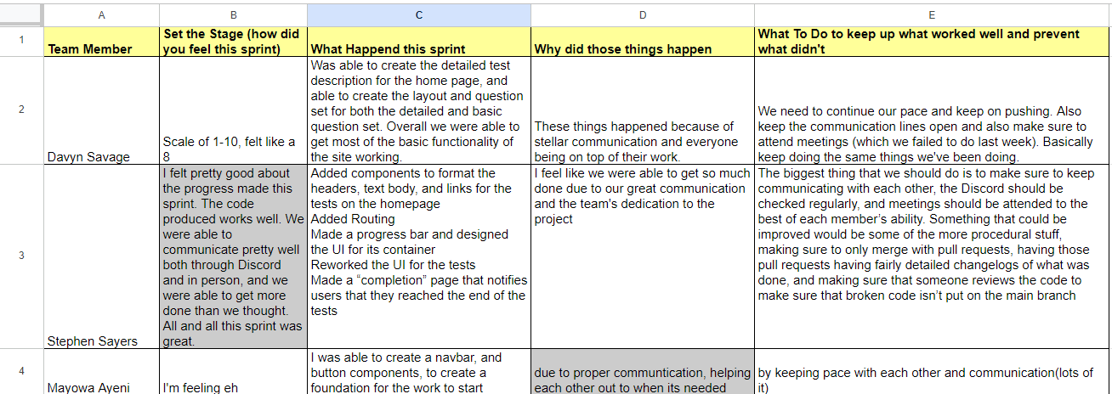

# 

# 

## 

## Sprint Tasks Sprint 1:



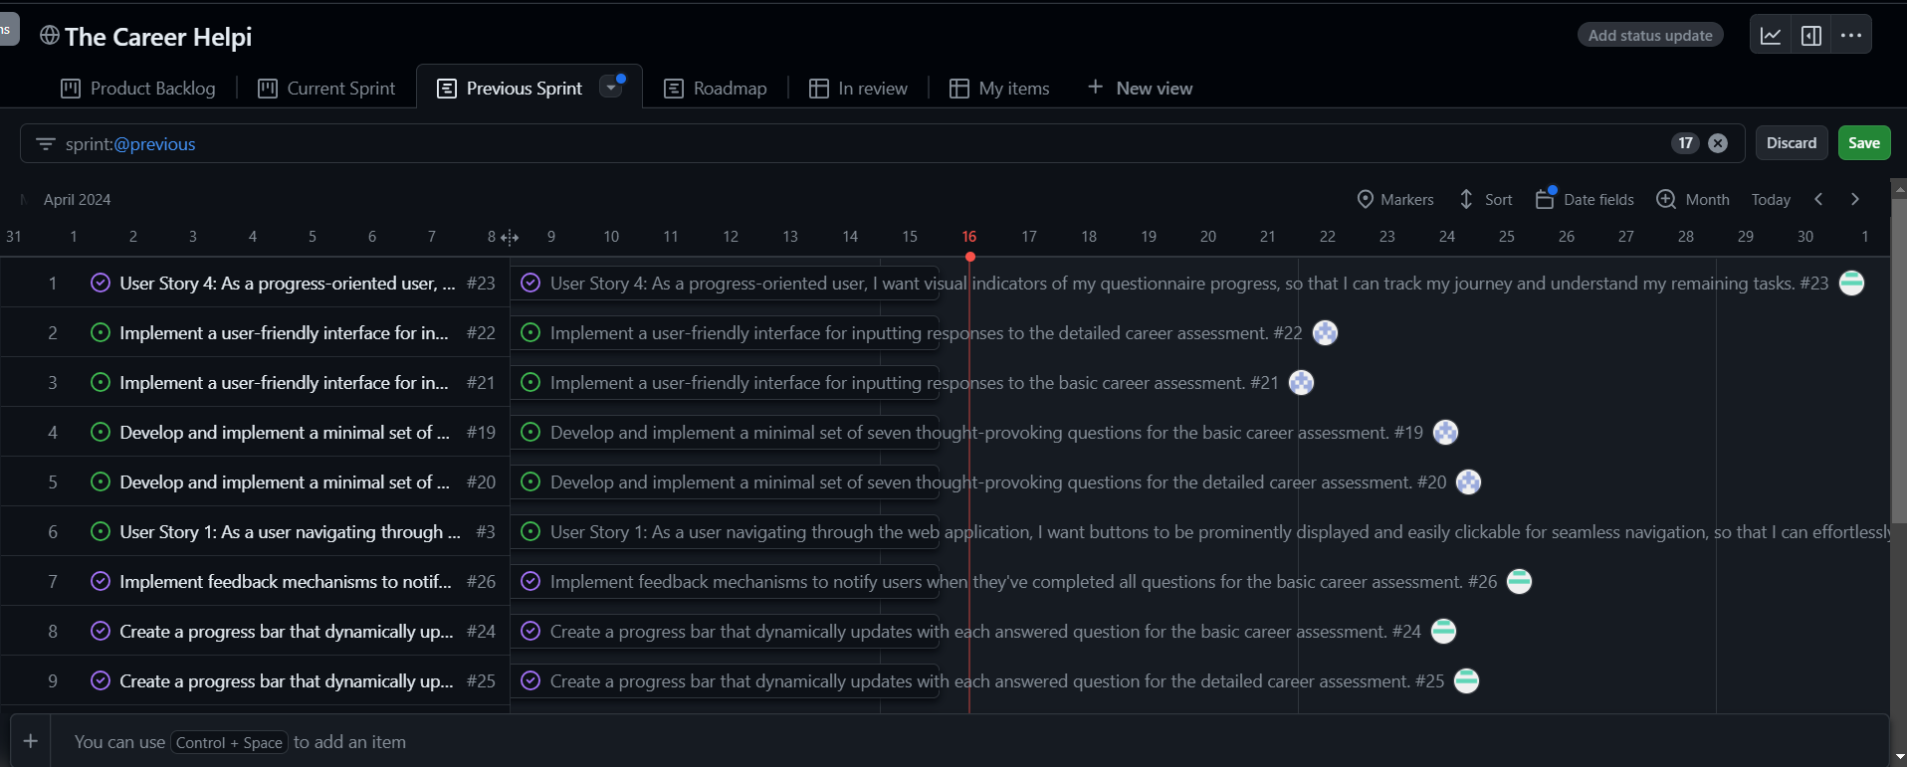

Finished through epic 4 with 16 total tasks finished

# 

# 

## Backlog of Sprint Tasks:

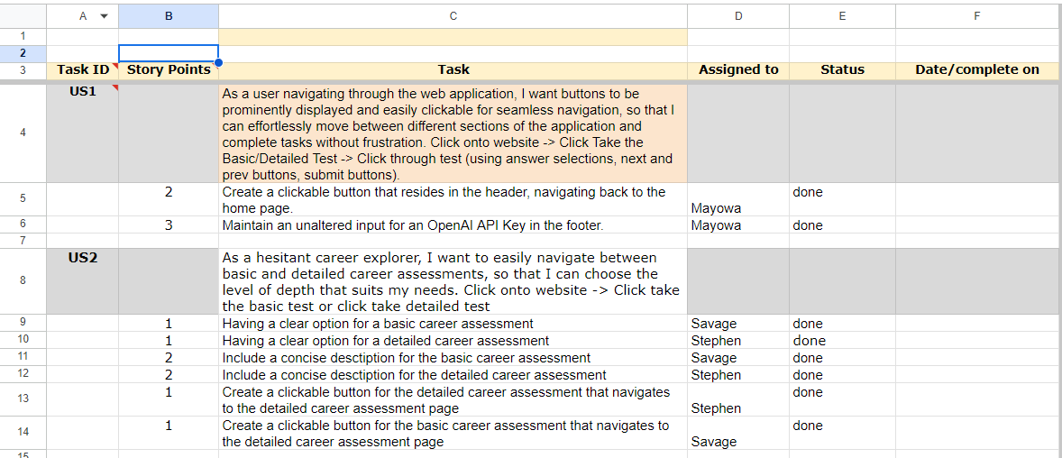

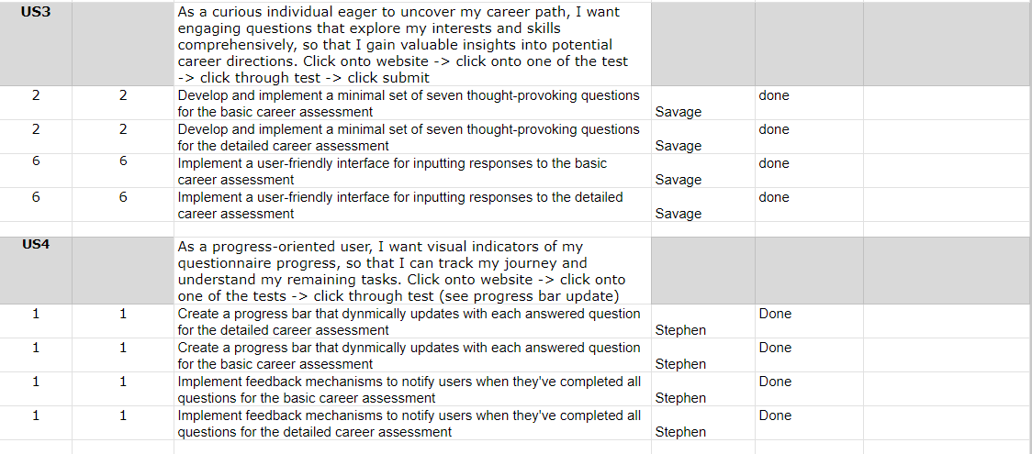

## Final Hours:

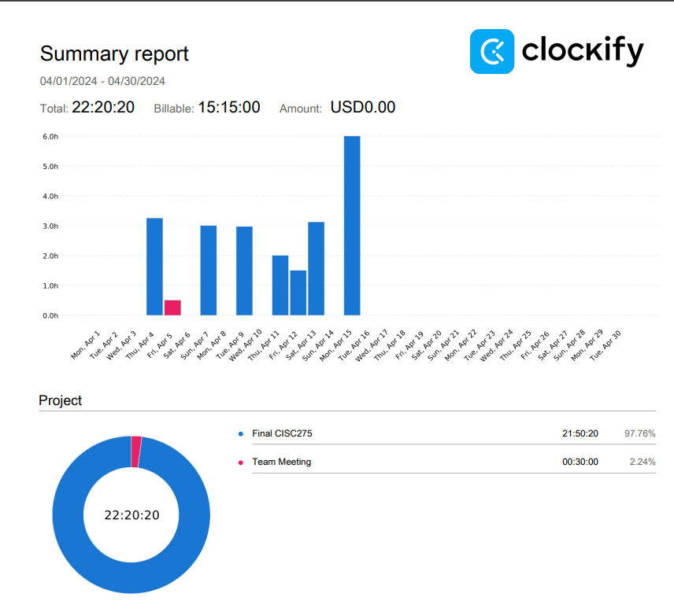

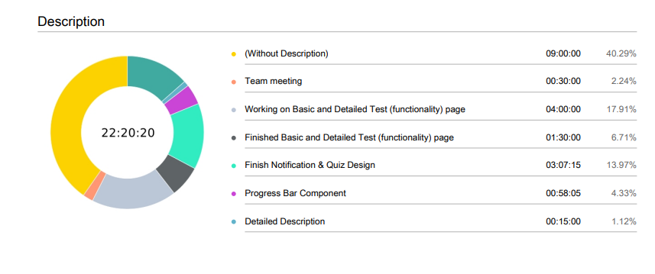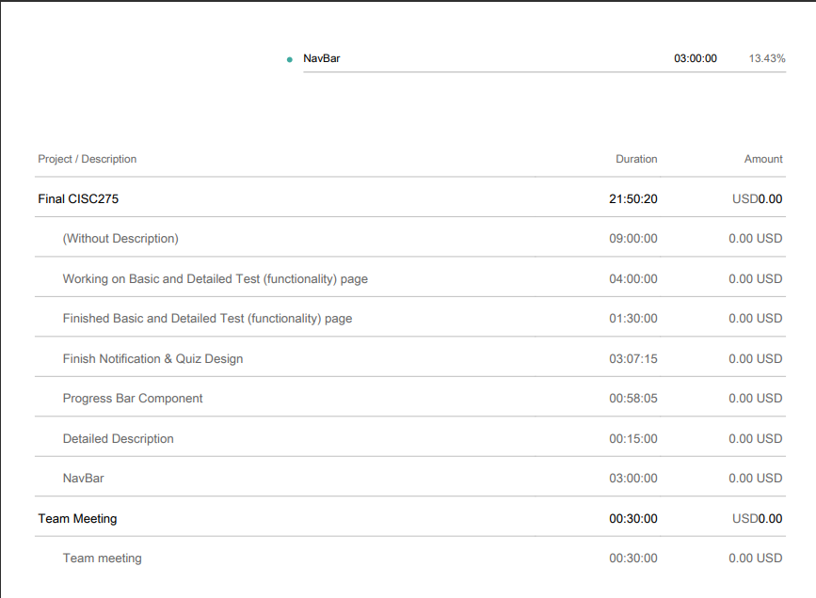

# Sprint 2

## Sprint Planning/Estimation

Our team first thought about adding more work to our plate from the last sprint, but we ultimately chose to reduce it because of conflicts, mostly from schoolwork from other classes. Even with this change, we are confident in our progress because there are just 12 tasks left. Given how labor-intensive Epic 4 is, our goal is to finish it before the end of this sprint. As we proceed, there's a chance we'll be able to take on more work. Mayowa is in charge of implementing ChatGPT during this sprint, Stephen will concentrate on creating the templates, and I, Savage, will offer assistance as needed. Considering our past achievements, we think our targets are doable. Furthermore, as we've observed, Epic 4 appears to be a placeholder for the implementation of Epic 5. (Response assisted by ChatGPT)

## 

## Product Backlog:

## Sprint Backlog:

## Hours:

Mayowa:

Stephen:

Savage:

## Sprint Review:

The sprint progressed fairly well, while we didn’t get every task done we did make good progress and have enough time to get all remaining tasks done. Our teamwork has been superb with everyone able to take and give criticism. Something we are still working the kinks out on is team meetings. While we did have both team meetings this sprint we want to just be more consistent on the topics we talked about. We were able to get test up for the navbar and other general navigation, and also test to check that components are working properly. We got the test up and running and a framework for the results page. Going forward we would like to finish polishing the site’s UI (some groups have commented that it’s hard to read and hard on the eyes at times), we also want to decrease the loading time it takes to get results and fully finish Chat implementation. If we have extra time at the end we might look to do some beta testing on our website. But for now we are more focused on getting everything finished.

## Retrospective: Table of Responses:

## Retrospective: Summary of Responses:

In this sprint team members mostly felt good about how it had gone, a notable deviation from this was Mayowa who felt that classwork from other classes was hampering his ability to remember and be as on top of things as he wanted to. After talking to the team lead the decision to send more frequent reminders about pending tasks was the solution. Everyone so far has been pleased with each other’s work and the management of tasks hasn’t seemed to be an issue. Communication is something the team as a whole would like to improve and remains the biggest issue we’d like to tackle. The team feels confident that we can achieve all that we’ve set for ourselves by the end of this sprint and have a functioning website by the end.

# Sprint 3

## Sprint Planning/Estimation

We talked about the five remaining tasks in our most recent sprint estimation and planning meeting. These tasks mostly involved ChatGPT implementation and a new addition of filtering results by major, which came about as a result of our WAAD phase. Given the conflicting comments we received from different groups, we thought about redesigning the user interface to make it more aesthetically pleasing. As a result, we might take a more cautious approach to design. During our demo, ChatGPT's sluggish reaction time was a major issue, and we got some recommendations from groups on how to make it better. In order to make sure that Chat stays clear and readable even on smaller screens, like those found on mobile phones, Mayowa will carry on with his work on implementation of Chat and fix some of the UI issues. Stephen will work on the verification processes for Chat, while Savage will focus on filtering by major. We are hopeful about getting our website finished by the end of this sprint, believing this to be a realistic goal. The new tasks being picked up (filtering by major/career and implementing validation checks) all carry with them 3 story points each suggesting we will have time to beta test and examine other aspects of our site.

## [Product Backlog:](https://github.com/users/dsavage0214/projects/1/views/1)

## [Sprint Backlog:](https://github.com/users/dsavage0214/projects/1/views/3?layout=table)



## Hours:

Savage:

Stephen:

Mayowa:

## Sprint Review:

This sprint we managed got all but one task done (error handling eluded us). The page has been updated to filter by career if one so chooses (this task was taken over by Stephen). We reviewed the comments we received on our last sprint and we implemented some changes to our site. We took the advice of loading items in one by one and the overall time of the results page has been cut down to about ~16 seconds per item. Mayowa finished implementing Chat into the website and the UI has gotten its final update. We couldn’t get to beta testing but otherwise a fairly successful sprint was had. We have also created a chatbot to help users and answer questions they may have about their results. Overall a successful sprint.

## Retrospective: Table of Responses:

## Retorspective: Summary of Responses

Davyn Savage described the sprint as nerve-wracking and acknowledged that he felt anxious because of the critical nature of the tasks and the pressure to finish them. The group included a new feature—a textbox that lets users filter careers by major—and made great progress in improving the user experience to guarantee ChatGPT responds more quickly. These upgrades were essential for improving user experience and simplifying interactions. Davyn pointed out that the reason the team's progress was slower than anticipated was that he and the other team members were all juggling other academic obligations at the same time. A slower rate of development resulted from this conflict of obligations. Better time management and more proactive work during earlier sprints, according to Davyn, could help alleviate end-of-semester stress in the future. The team’s sentiments mostly echoed this with Stephen feeling like this was his most poorly managed sprint. Mayowa felt slightly above average about this sprint (7/10) citing merge conflicts as the main stressor. Overall despite slower progress and a sort of rush to finish, the team managed to implement new features and mostly hit all the goals the set for the sprint.

## Project Debrief

This section provides a thorough evaluation akin to a Sprint Retrospective as we wrap up our involvement with The Career Finder Project, assessing our entire project experience. We are pleased to have reached important benchmarks, like the smooth incorporation of ChatGPT for real-time help and noteworthy improvements to UI designs that guarantee the best possible user experience. Despite these achievements, we still had to deal with obstacles like juggling project demands with academic requirements and overcoming unforeseen technical difficulties, especially with API interfaces. These experiences made it clear that, in order to preserve consistency and clarity in team interactions, an earlier and more thorough testing phase and improved communication tactics must be put into place. This project taught us the benefits of a collaborative workplace that actively encourages all team members to offer ideas and input, as well as the necessity of flexibility and adaptability when faced with unforeseen problems. Had we another go at the project we would most likely would have assigned more tasks at the beginning when we had the least external commitments and implemented discord meetings initially instead of switching halfway through the project. As mentioned before flexibility and adaptability were extremely important and helped us persevere through the challenges we faced over the course of this project. (Response assisted by ChatGPT)

## Appendix

### Final Presentation

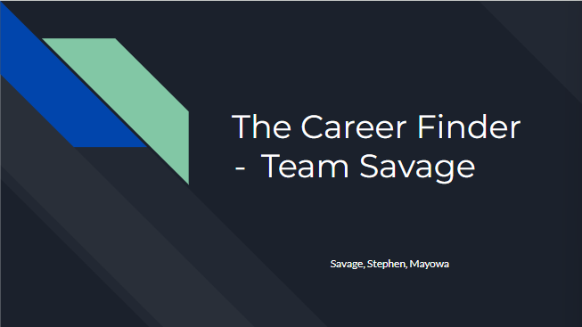

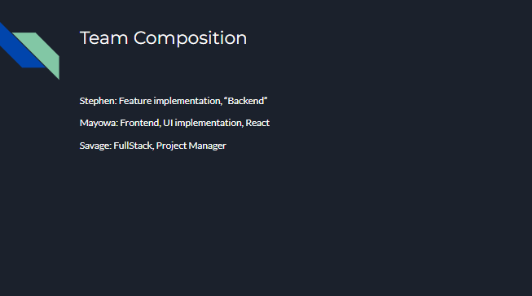

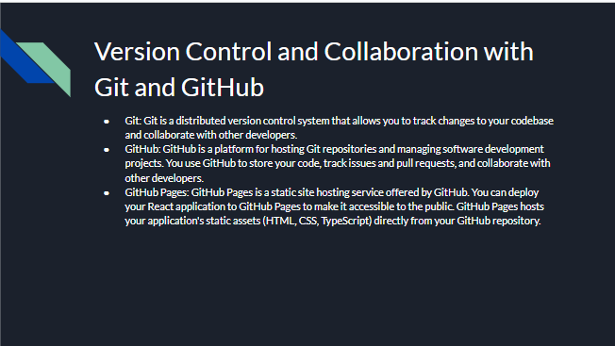

### Context Analysis, WAAD Creation & User Story Generation

### Contextual Inquiry & Analysis

### Setup

### Initial Design (Wireframe)

### Sprint Planning Meetings

Sprint 1:

Sprint 2:

### Sprint Reviews

Sprint 1:

Sprint 2:

